0th level: Amanuensis: Copy nonmagical text.
1st Level:
Anarchic WaterM: Makes chaotic-aligned anarchic water.
Axiomatic WaterM: Makes lawful-aligned axiomatic water.
Blessed Aim: +2 bonus for allies’ ranged attacks.
Blood Wind: Subject uses natural weapon at range.
Cold Fire: Fire becomes blue and white, emits cold.
Conviction: Subject gains +2 or higher save bonus.
Delay Disease: Ravages of disease staved off for a day.
Dispel Ward: As dispel magic, but affects only wards.
Ebon Eyes: Subject can see through magical darkness.
Faith Healing: Cures 8 hp +1/level (max +5) to worshiper of your deity.
Foundation of Stone: +2 AC, +4 bonus to resist bull rush and trip attacks.
Grave Strike: You can sneak attack undead for 1 round.
Guiding Light: +2 on ranged attacks against creatures in illuminated area.
Healthful Rest: Subjects heal at twice the normal rate.
Ice Gauntlet: A spiked gauntlet of ice forms around your fist.
Incite: Subjects can’t ready actions or delay.
Inhibit: Subject delays until next round.
Ironguts: Subject gains +5 bonus on saving throws against poison.
Light of Lunia: You radiate silvery light, which you can expend as 2 bolts that deal 1d6 damage.
Moon Lust: Subject obsesses about moon, is fascinated or dazzled.
Nightshield: You gain resistance bonus on saves, and spell absorbs magic missile damage.
Nimbus of Light: Light illuminates you until released as an attack.
Omen of PerilF: You know how dangerous the future will be.
Portal Beacon: You grant others knowledge of a magic portal’s location.
Resist Planar Alignment: Subject can resist penalties for being of an opposed alignment on an aligned Outer Plane.
Resurgence: You grant subject a second chance at a saving throw.
Sign: You gain +4 bonus on next initiative check.
Snowshoes: Subject walks easily on ice and snow.
Spell Flower: Hold the charge on one touch spell per forelimb.
Summon Undead I: Summons undead to fight for you.
Updraft: Column of wind lifts you aloft.
Vigor, Lesser: Creature heals 1 hp/round (max 15 rounds).
Vision of Glory: Subject gains morale bonus equal to your Cha modifier to one saving throw.
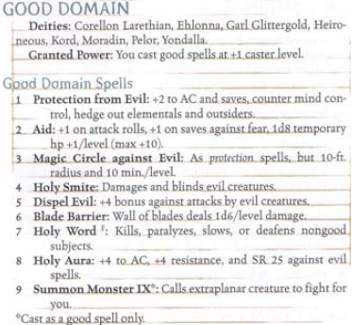
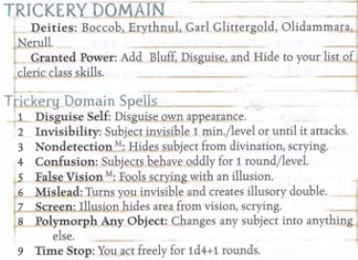
Wings of the Sea: +30 ft. to subject’s swim speed.

